TACO BELL HAWAII HELPS SECURE MORE THAN $230,000 FOR
TWO HAWAII YOUTH NONPROFITS
Boys & Girls Club of Hawaii and Junior Achievement of Hawaii receive grants through Taco Bell Foundation’s record $32 million national investment
HONOLULU, HI (September 21, 2026) – Two Hawaii nonprofits will receive a combined $234,750 from the Taco Bell Foundation to expand programs that help local young people build skills, prepare for college and careers, and pursue their goals. The grants, supported locally by Taco Bell Hawaii include:

- $175,000 to Boys & Girls Club of Hawaii
- $59,750 to Junior Achievement of Hawaii

The Hawaii grants are part of the Taco Bell Foundation’s record $32 million Community Grants investment supporting 700 nonprofit organizations nationwide in 2026.

“We’re proud to support Boys & Girls Club of Hawaii and Junior Achievement of Hawaii, two organizations that have a tremendous impact on young people across our state,” said Kevin Kurihara, President, RBD Hawaii Restaurants Limited, a subsidiary of RBD US Holdings, Ltd. “As a local company, we see firsthand the importance of giving Hawaii’s young people the skills, confidence and opportunities they need to succeed. We’re grateful that our customers and Team Members can help support that work right here at home.”

SUPPORTING HAWAII’S YOUNG PEOPLE

The Taco Bell Foundation’s Community Grants program takes a locally driven approach to giving. Taco Bell franchisees help identify and nominate nonprofit organizations doing meaningful work in the communities they serve, helping direct Foundation resources to organizations that understand local needs.

Boys & Girls Club of Hawaii and Junior Achievement of Hawaii provide programs that help Hawaiʻi youth develop valuable life and career skills, connect with mentors and prepare for their futures.

SMALL DONATIONS ADD UP TO LOCAL IMPACT
The Community Grants program is fueled in part by Taco Bell customers who choose to Round Up their order totals to the nearest dollar. The average Round Up donation is just 43 cents, but collectively those contributions make a significant impact. In 2025 alone, customers contributed more than $51 million through Round Up.

Taco Bell Hawaii Team Members help bring the program to life at restaurants across the state by giving customers an easy opportunity to contribute.

Round Up also helps support the Taco Bell Foundation’s Live Más Scholarship program, which provides scholarships to young people pursuing their educational goals and passions. In 2026, the Foundation awarded a record $14.5 million in scholarships to more than 1,500 recipients nationwide.

To learn more about the Taco Bell Foundation and the Community Grants program, please visit https://www.tacobellfoundation.org/who-we-support/.
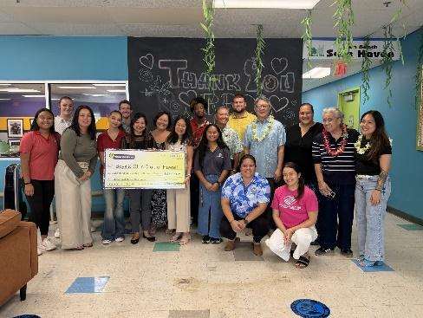

Boys & Girls Club of Hawaii Check Presentation at their Hale Pono Ewa Beach Clubhouse. Pictured are Boys & Girls Club of Hawaii leadership and staff alongside Taco Bell Hawaii management.
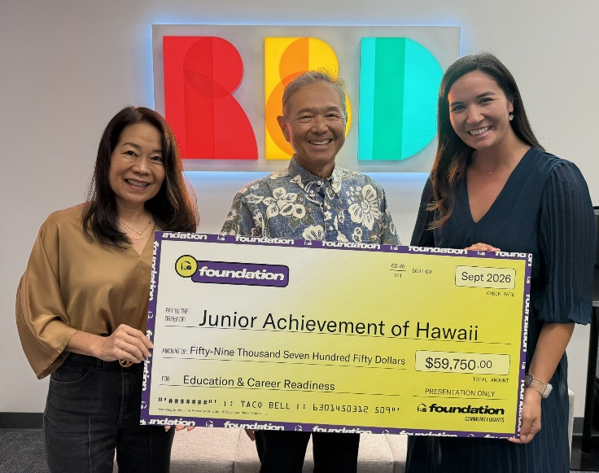

Jr. Achievement of Hawaii Check Presentation (left to right): Leah Allen, Marketing Director, RBD Hawaii Restaurants Limited; Kevin Kurihara, President, RBD Hawaii Restaurants Limited; and Jayann Laniauskas, State Program Manager, Junior Achievement of Hawaii.

About RBD Hawaii Restaurants Limited
RBD Hawaii Restaurants Limited operates 57 Pizza Hut and Taco Bell restaurants throughout the
Hawaiian Islands and 13 Pizza Hut and Taco Bell restaurants in Guam and Saipan.

About Taco Bell Foundation
Taco Bell Foundation, Inc. is a 501(c)(3) public charity that empowers the next generation to pursue their passions by breaking down barriers to education and providing resources to help young people chase their boldest ambitions. Since 1992, the Taco Bell Foundation has reached more than 13 million young people across the country and has awarded more than $278 million in grants and scholarships, focused on education and career readiness. For more information about the Taco Bell Foundation, visit www.tacobellfoundation.org.
# # #

