TWO HAWAII HIGH SCHOOL SENIORS EACH RECEIVE $25,000 LIVE MĀS SCHOLARSHIPS
AS TACO BELL FOUNDATION AWARDS RECORD $14 MILLION NATIONWIDE

Celebrating a decade of fueling passions, the Taco Bell Foundation’s Live Más Scholarship continues to support driven Team Members at RBD Hawaii Restaurants Limited

HONOLULU (April 30, 2025) – The Taco Bell Foundation’s Live Más Scholarship program is celebrating its 10th anniversary with its largest scholarship distribution yet: $14 million awarded to passionate young people across the country. Of that total, a record-breaking $4.5 million is going directly to Taco Bell Team Members—underscoring the Taco Bell Foundation’s commitment to the very people who bring the brand to life every day. Among this year’s winners are two Team Members from RBD Hawaii Restaurants Limited, each receiving $25,000 scholarships to help fuel their dreams.

“It’s rewarding to see this scholarship’s impact in helping local students who embody the values of hard work and a commitment to positively impacting their communities,” said Kevin Kurihara, President of RBD Hawaii Restaurants Limited. “By partnering with the Taco Bell Foundation, we can equip these students with the tools necessary to pursue their dreams and create positive change.”

To date, the Taco Bell Foundation has awarded over $64 million in Live Más Scholarships to over 3,000 recipients, including more than 1,000 Taco Bell Team Members. Thanks to fanpowered donations through the Round Up program at checkout, the impact keeps growing. Just 44 cents—the average donation—goes a long way: scholarships for Taco Bell fans are funded entirely through Round Up, while Team Member scholarships are made possible by contributions from Taco Bell Corp. and Taco Bell franchisee like RBD Hawaii Restaurants Limited.

In this application cycle, passions spanned every field, from food science and business to emergency medicine and engineering. Check out how two inspiring 2025 RBD Hawaii Restaurants Limited Live Más Scholars are making an impact:

- Kingsten Cambra: As a senior at Aiea High School, Cambra is weighing his college options between the University of Southern California and Santa Clara University. He currently interns at the Richardson School of Law and serves as captain of the Debate and Math teams. His mother’s involvement in the Kapiolani Medical Center nurse strike sparked his passion for law. With support from the Live Más Scholarship, Kingsten plans to major in economics, focusing on pre-law. He is a Team Member at Taco Bell Ka Makana Ali’i.

- Katelyn Pascua: Pascua is a graduating senior at Waipahu High School and plans to apply to the University of Hawai‘i at Mānoa to pursue a bachelor’s degree in accounting. Her interest in financial literacy and community service was inspired by her mother, who prepares taxes for their family. Building on that inspiration, Pascua volunteered with the Volunteer Income Tax Assistance (VITA) Program, gaining hands-on experience helping others with their tax filings. Through the Live Más Scholarship, she hopes to continue her education and provide financial guidance. Pascua is a Team Member at Taco Bell Waipio.

THE LIVE MÁS SCHOLARSHIP DIFFERENCE

The Live Más Scholarship isn’t based on GPAs or test scores—it’s built around passion. Designed for creative thinkers, cultural rebels and bold dreamers, the program invites applicants to share their story through a two-minute video, spotlighting how they plan to make an impact. In return, if selected, they join a supportive, purpose-driven community and gain access to mentorship, career workshops, internships, and networking opportunities, making the scholarship more than just financial support, but a launchpad for what’s next.

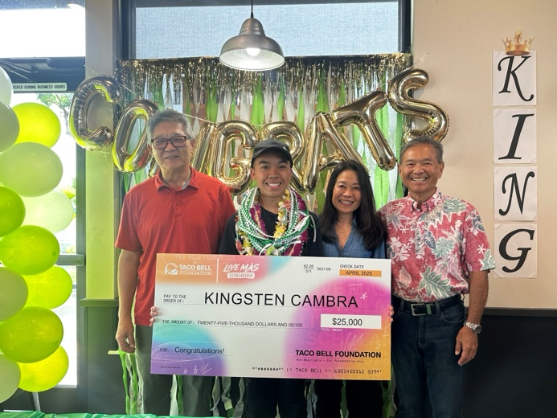

From Left to Right: Yong Min Kim, Kingsten Cambra, Leah Allen, Kevin Kurihara.

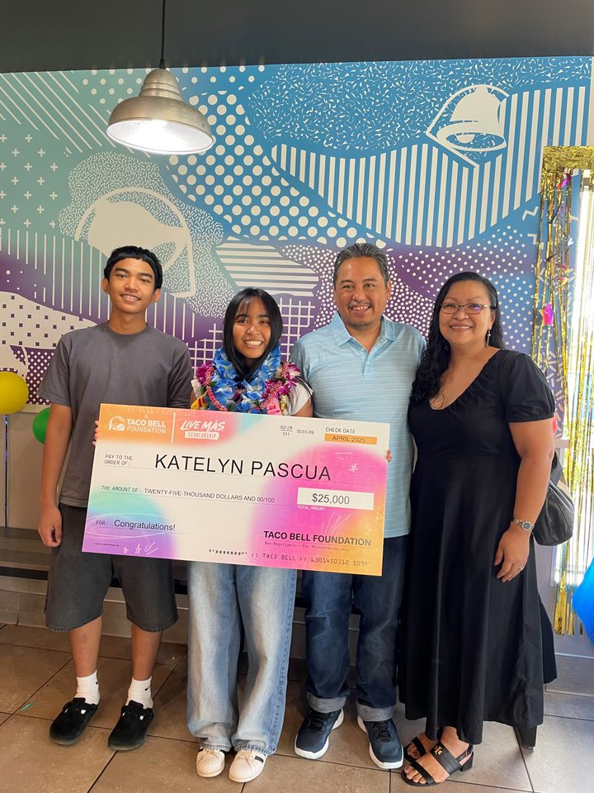

Pictured is Katelyn Pascua with her family, friends, and Taco Bell Hawaii Management.

About Taco Bell Foundation
Taco Bell Foundation, Inc. is a 501(c)(3) public charity that helps break down barriers to educate and inspire the next generation of America's young leaders. Since 1992, the Taco Bell Foundation has reached more than 9 million young people across the country and has awarded more than $189 million in grants and scholarships, focused on education and career readiness. This impact is made possible through a range of programs, including Community Grants, which support more than 450 nonprofit organizations nationwide. For more information about the Taco Bell Foundation, visit www.tacobellfoundation.org.

About RBD Hawaii Restaurants Limited
RBD Hawaii Restaurants Limited operates 57 Pizza Hut and Taco Bell restaurants throughout the Hawaiian Islands and 13 Pizza Hut and Taco Bell restaurants in Guam and Saipan.

# # #

