**RBD HAWAII RESTAURANTS LIMITED CELEBRATES NEW OFFICE LOCATION**

**April 29, 2025**

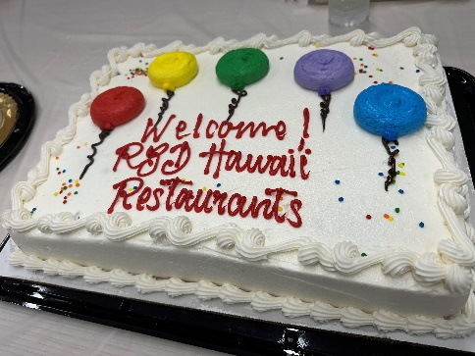 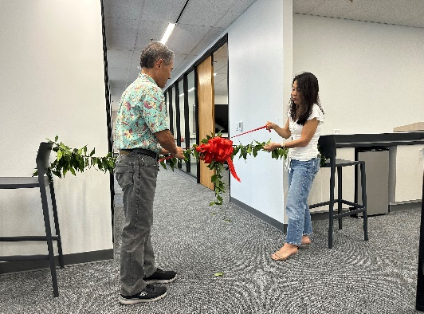 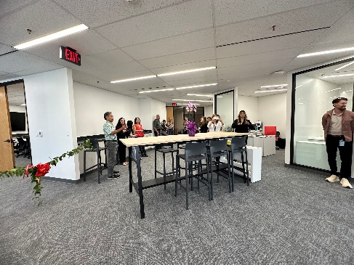

In April 2025, RBD Hawaii Restaurants Limited celebrated its new name and office location. Office staff and above-store leaders came together for an afternoon of connection and celebration. Kevin opened the event with a warm welcome and a nostalgic look back at our history of office moves, followed by a heartfelt blessing from Pastor Randy Pacarro.