GUALO RAI COMMERCIAL CENTER PIZZA HUT REOPENS
MAY 31, 2023
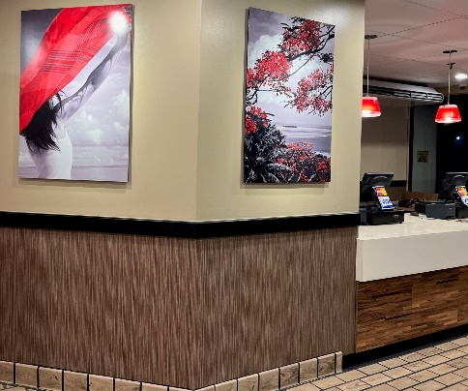

On May 10, Pizza Hut Saipan reopened after weeks of renovating the restaurant. Pizza Hut Saipan features new artwork and branded designs to welcome customers back into the store. Try our new Cheesesteak pizza and melt for a limited time by calling our Saipan location at 1-670-235-9333.
