KILAUEA TACO BELL GRAND OPENING

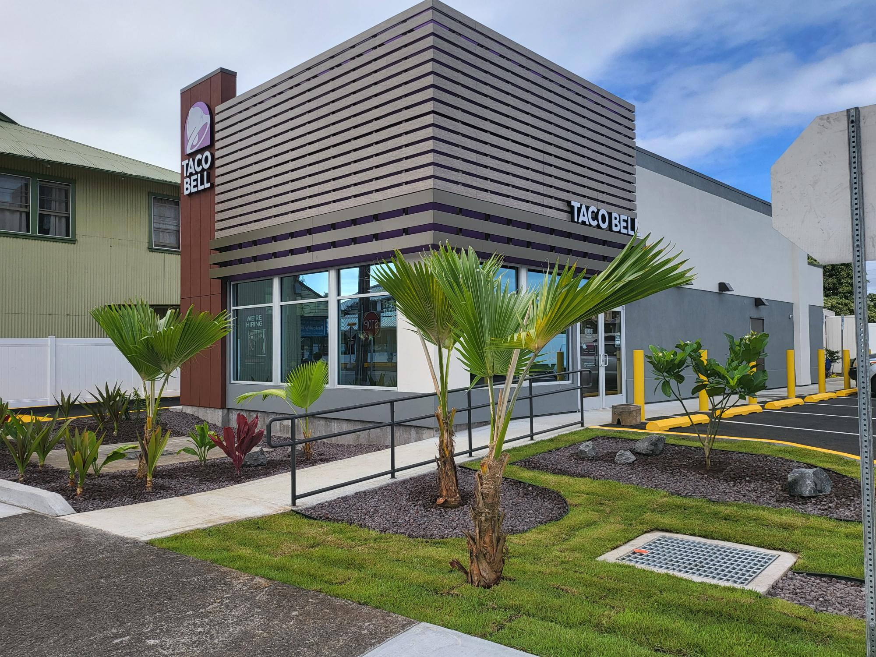August 26, 2022

A brand new Hilo Taco Bell celebrated its grand opening on August 26, 2022. This new restaurant located at 326 Kilauea Ave features the latest technology including digital menu boards and convenient kiosk ordering stations. Dining rooms are open from 7am – 10pm daily and drive thru is available daily from 6 AM – 12 AM. Skip the line by placing orders online at tacobell.com or via the Taco Bell mobile app. Come visit our newest Taco Bell in Hilo on the Big Island!

